CS551 Lab2 Report RAKESH VIDEM

# Mobile Web Client Application using Javascript, HTML5, CSS3, jQuery Mobile

**Application Name:** Know Your Kansas City

**Description:**  Know Your Kansas City is a Mobile Web client Application developed to know about Kansas City. The main features of the app are

* To find Geo-Location of Kansas City.
* To find directions in Kansas City,
* Kansas City tour Video.
* Kansas City places to visit.

This app is built using the Javascript, HTML5, CSS3 and jQuery. Used Opera Mobile Emulator to generate the screens to view this mobile web app.

Jsfiddle Link for the app - <http://jsfiddle.net/rvbnd/ZHPnz/22/>

**Screen Shot of jsfiddle:**

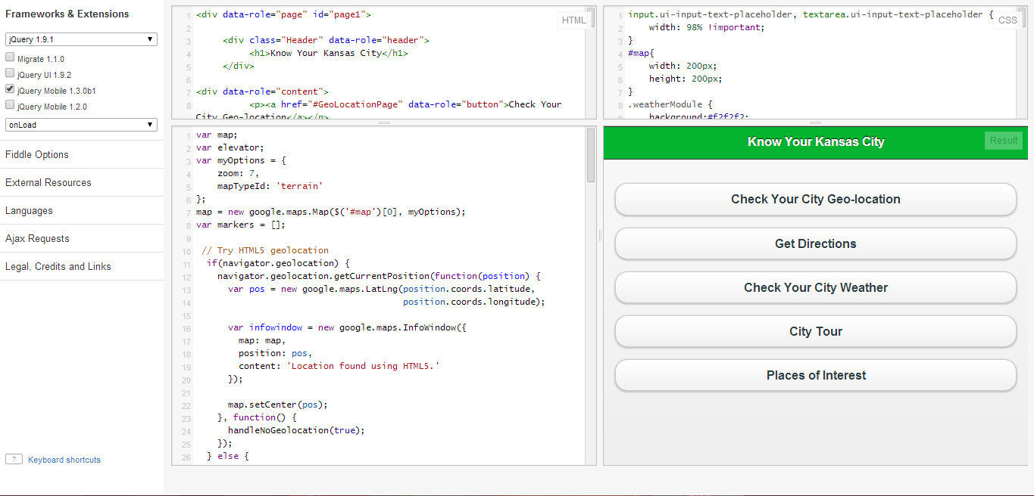

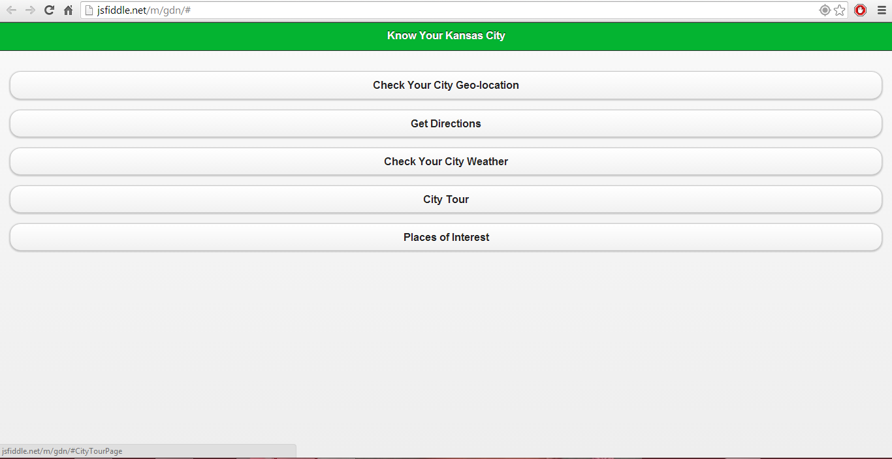

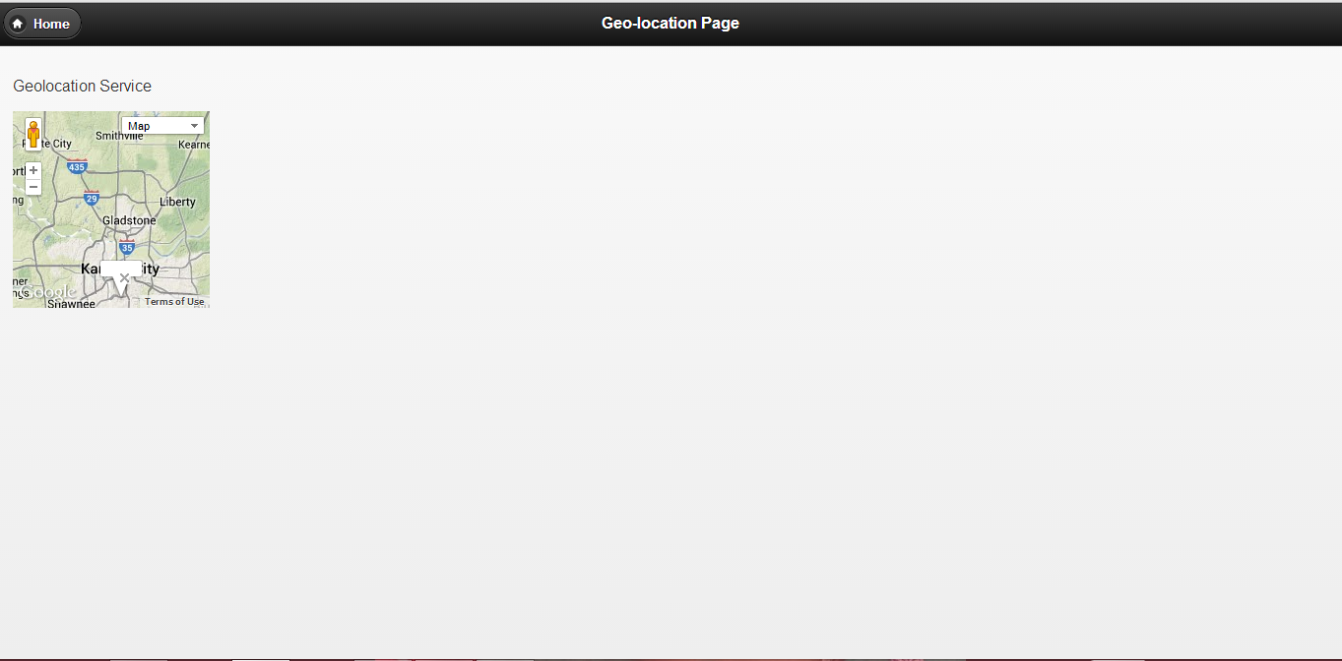

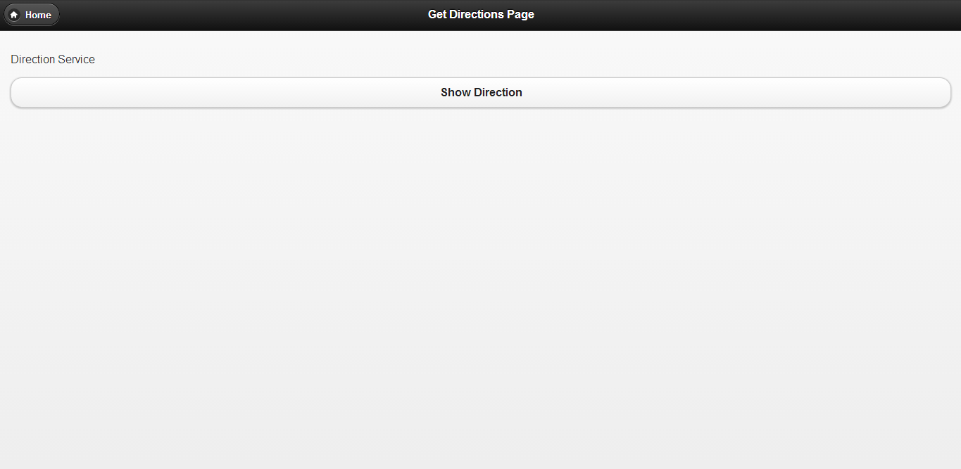

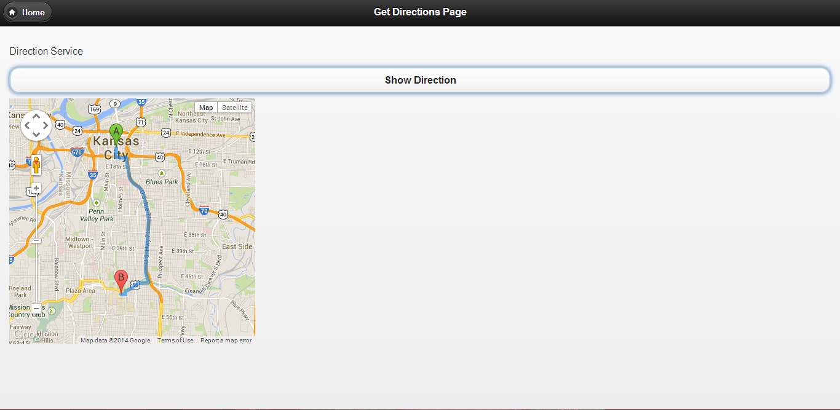

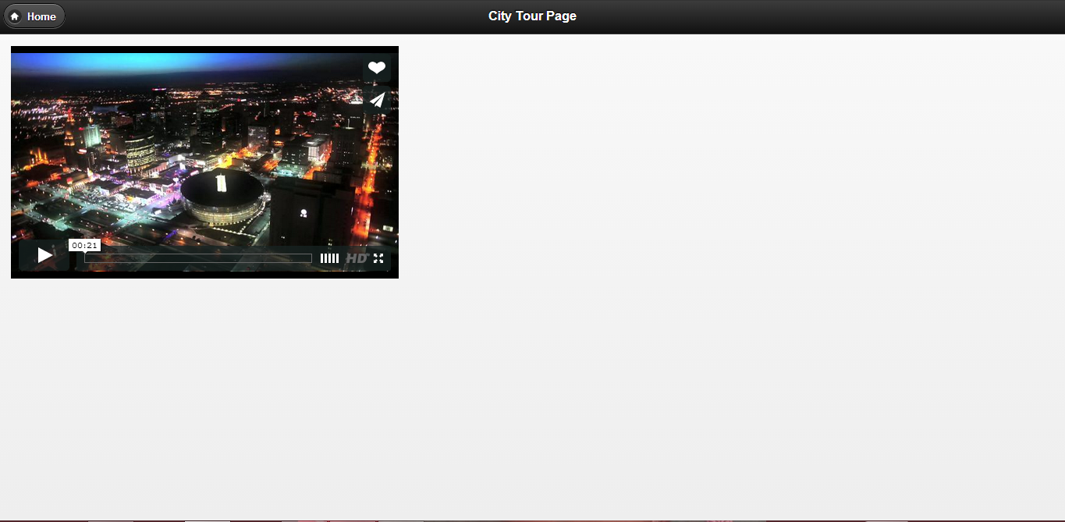

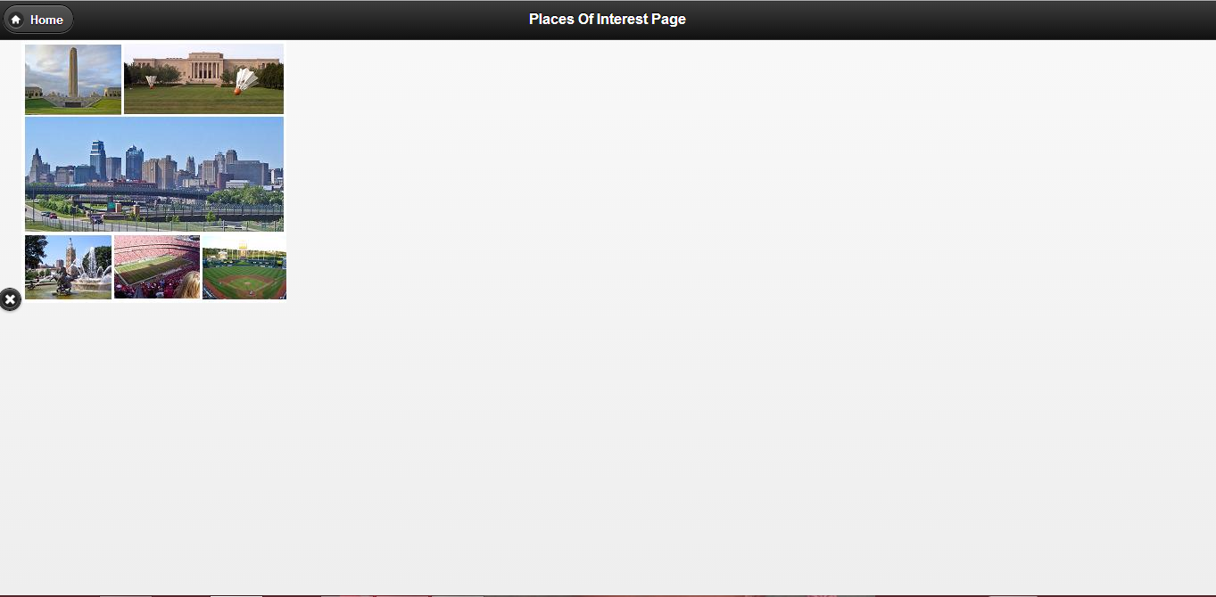

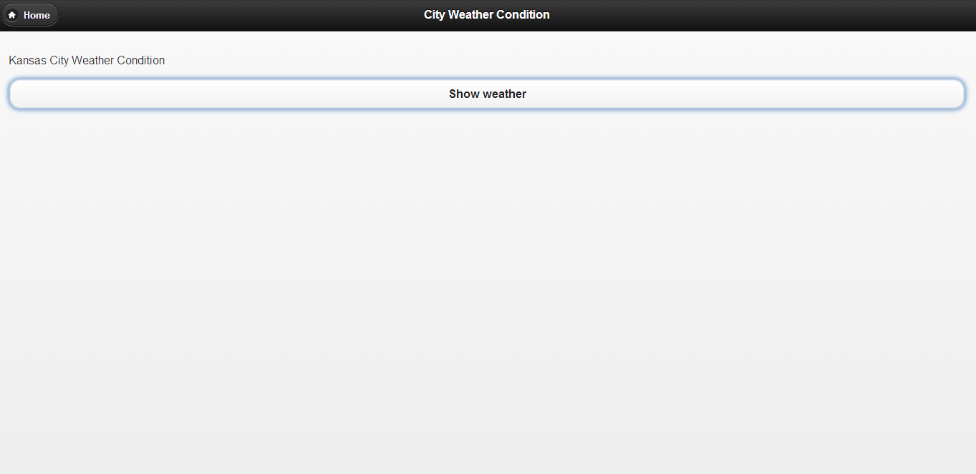

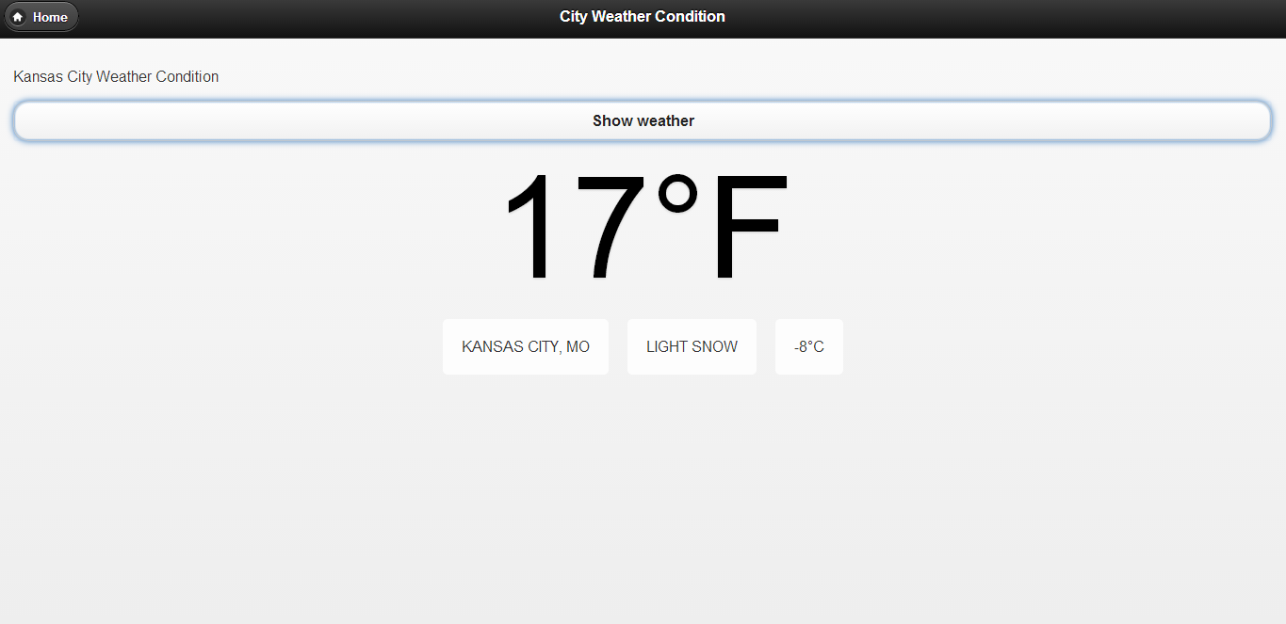

**Opera Mobile App View**

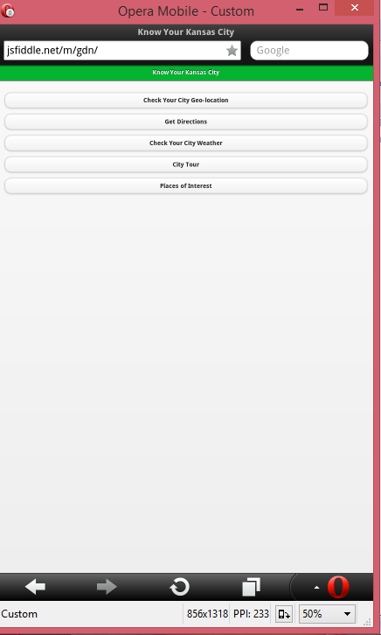

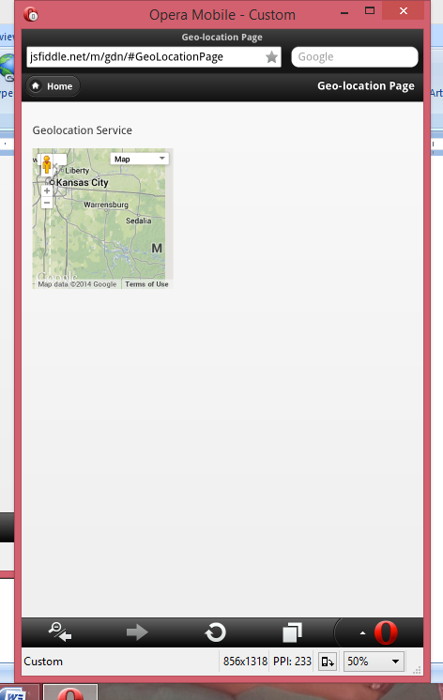

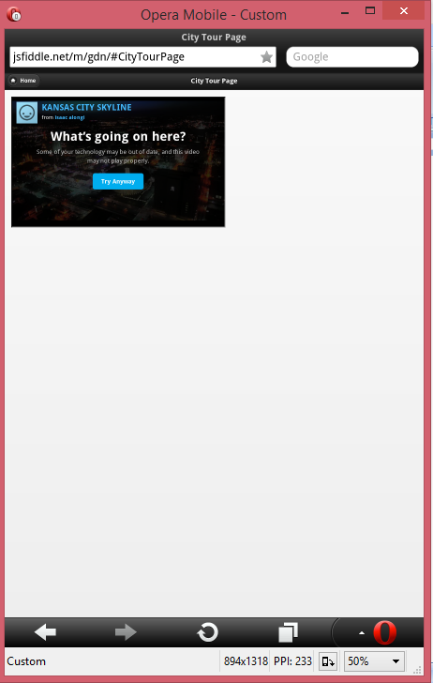

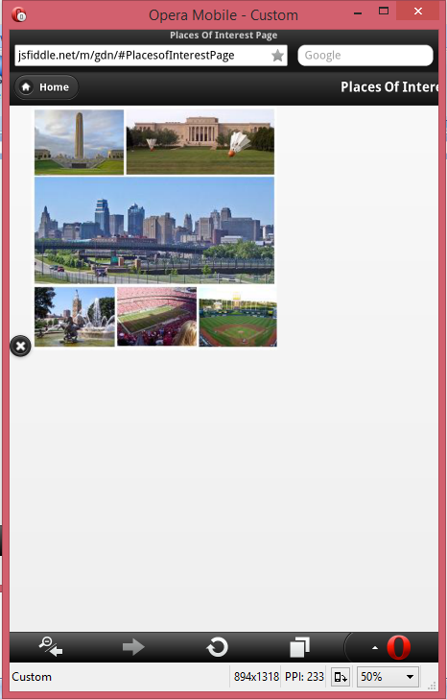

**Source Code:**







**Feature Scope:**

This app can be implemented for all the cities with many features like History of cities, Pointers in the city and many more.